**Project Report On**

**“JSK.IN”**

**Submitted to**

Department of Computer Science

Faculty of Technology & Engineering

The Maharaja Sayajirao University of Baroda

Year 2013-14



Faculty of Technology & Engineering

The Maharaja Sayajirao University

**TABLE OF CONTENTS**

1. Abstract Description on project
2. Project Overview
3. Snap Shots
4. Data Directory
5. E-R diagram
6. DFD

**🡪 ABSTRACT DESCRIPTION ON PROJECT**

* **Description ::**

This website is for online Selling of 1st Hand as well as 2nd Hand Items. It’s the place where Buyers meet the Sellers. It uses basic feature of ASP.NET and SQL Database.

* **Project Modules ::**
* **Search ::**  It will enable the user to find & Select the item of his preference , satisfying criteria of Item Type , Price range Features, etc.
* **User Information :** By this feature, this website will save the Database of the user who have visited and used website previously to help them to make their purchasing easier.
* **To Update Post :** By this feature , any user can post his/her post about the item he/she wants to sell with full specification , using which interested user can contact that person to get it.
* **Latest Updates :** This features will make continuous update on the recent post just posted on the website .
* **User Account Management ::** It will give accounting facility to each user , for handling their Ads that they have posted , & to receive any request from the interested buyers for that particular product.
* **Admin Panel :** This module of the website enable the Admin , the person to which the website has been handed over , to …
* **Send Messages to any no. user at a time to contact to registered users**
* **To delete Ads having invalid information , not related to any satisfying category**
* **To delete any particular user**
* **Tools ::**
* **Front –End ::** C# ASP.NET and HTML4
* **CSS**
* **Database ::** Microsoft SQL

**🡪PROJECT OVERVIEW**

**🡪*Project Profile ::***

|  |  |  |
| --- | --- | --- |
| **Project Title** | JSK.IN | |
| **Aim of Project** | To develop a Online Shopping Website | |
| **Project Description** | Our objective is to develop a website, which can behave as a platform where *Buyers meet the Sellers.* | |
| **Tools Used** | Front End | ASP. net 4.0 |
| Back End | Microsoft SQL |
| Other Tools | Visio 2013 |
| **Submitted To** | Department of Computer Science,  Faculty of Technology & Engineering,  The Maharaja Sayajirao University of Baroda | |

* **Project Description ::**
* **What this Website is all about and which modules it contains and how it really works ?**

**🡪**

This is online Shopping Website – *A website where Buyers meet the Sellers.*

It works as a platform , where interested user wishing to Sell his , either 1st Hand or 2nd Hand Products/Items can post on the wesite and all the information about the Seller and the Buyers , whose desire are exactly satisfied by Specification provided by the Seller , can contact him buy Simply sending Email from our website so the Seller can contact him, as well as all the information about Seller will also be provided along with the product detail , so Buyer can also immediately contact to Seller if he wish….!!! ☺

**Modules ::**

**All the modules of website are listed as below ::**

* **Home Page ::** This is the main Home Page of the website , which contains category wise List of all the items Such as *Mobile Phones,Cars,*etc.

By using this Direct Link user can directly get redirected to particular category Ads , thus by *“Easing User Interface.”*

* **Post Free Classified ::** This Page is for the Seller , whoever want to Post Ad about any product he/she want to sell , it doesn’t matter whether the user has already been registered or not or if he/she has already used this *glorious* website before this. And if he has gone through once, then no need to adding all details again and again, all details will be auto filled by us based on already registered emailed ,thus by another “*Easing User Interface”.*
* **RegisterUser ::** This page,RegisterUser, enable a new user to get himself registered.Although most of internet user found it most tedious task in getting registered themselves, but it will ultimately result in an much easier task in posting new Ads as well as in interecting with user.
* **YourAds** :: It’s the page that will contain List of all the Ads that seems to satisfying Buyer’s wish, which may be either redirected directly from Home Page by Selecting Category or Searching through the Search Box.

User can also shorten this criteria by applying restriction based on State, City as well as based on price Range.

* **AdDetails**  :: When the user feels that he’s somewhat interested in particular product posted in ad and wishing to checkout all the details that Sellers has provided , AdDetails will be always there.

It also has a facility which enables Buyers to send Email to Sender so Seller can contact him , if interested…

* **SignIn Page** :: If user has already registered , then by Singing in into the account through SignIn Page he can go through all the information that he has posted , as well as he can remove Ad about any product if he has already sold it out , he can also check out all the Messages/Notifications that has been sent by any user.
* This Page also contain an important feature . If a user does don’t want to go through the most tedious tast of registering & creating an user account , then JSK.IN will always be there to create an account on behalf of him , so he can access all the ads that he has posted without creating an accout by simply providing us the EmailId using which he has posted Ads before.
* **User Home** :: It’s the home Page of all the user after getting logged in , it will enable user to Read all messages that he has received , manage his account credentials and change his Updated Post’s Status.
* **AdminLogin** :: AdminLogin is the Login page for Admin of the wesite , which will give him control over full website management , after getting Logged In.
* To provide more privacy , it has been separated from all other page’s path and Admin Can only get to that page by typing full URL , provided by us, into Address Bar.
* **AdminSendMessages ::** If Admin wants to send any messages to any particular user, i.e.,*To sending warning for not Posting any invalid post again ,* or if he want to send Email to all the user at a time ,i.e.,*informing him about any schemes or wishes or whatever*, he can do so using this provided.
* **AdminRemoveAccount**  :: If admin comed to know that this particular is not using his account, anyhow, since a long time, so to reduce data traffic he can remove his account.
* **AdminAdManagement** :: The most important duty of any Admin to continue his site to be in working position , is to manage whatever is being posted everyday on his website.
* If he founds any Ad violating his privacy rule, or any other information which may lead in creating Bad Image in front if people, then Admin can remove Such Ads using AdminAdManagenent.
* **SNAP SHOTS ::**

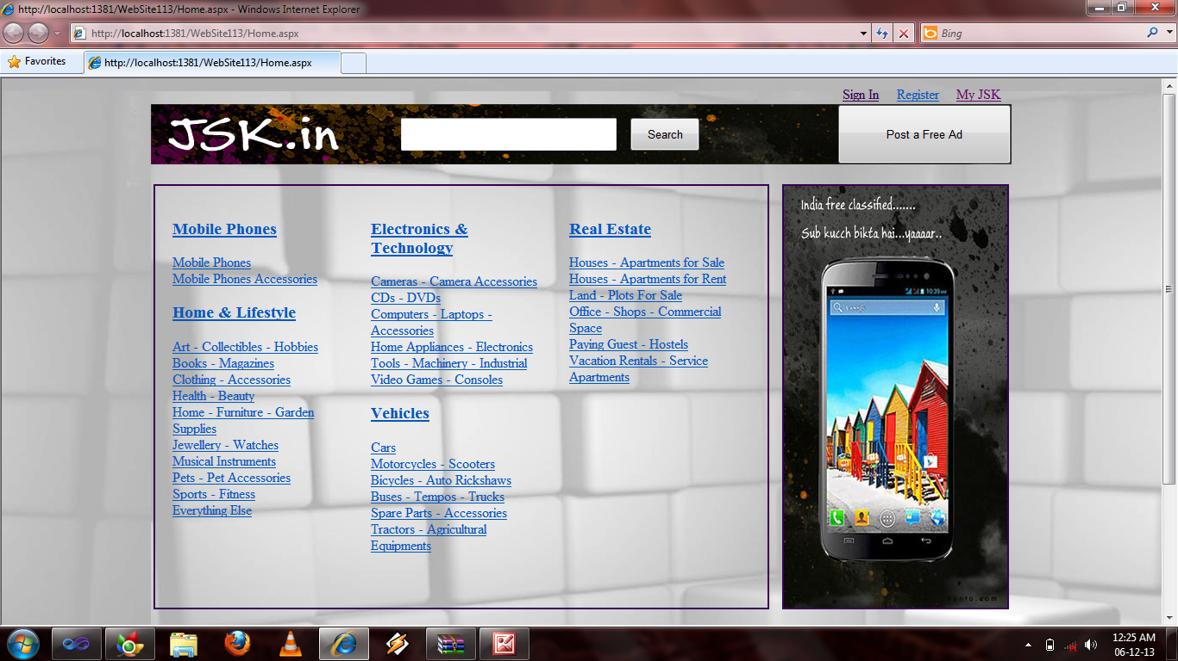

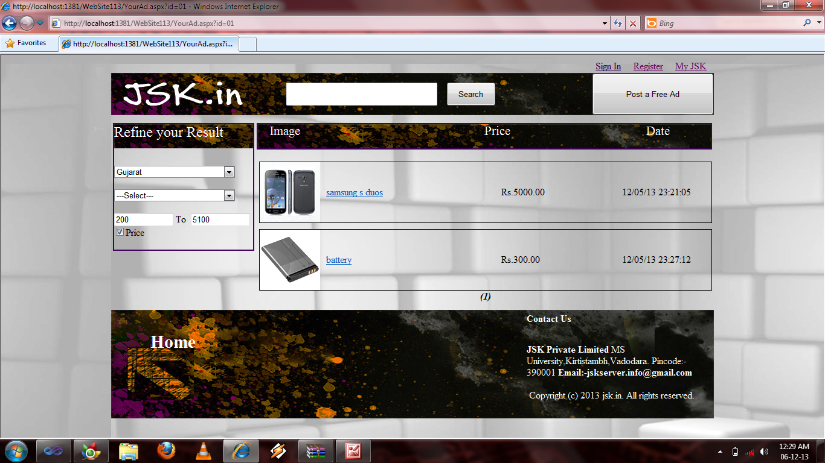

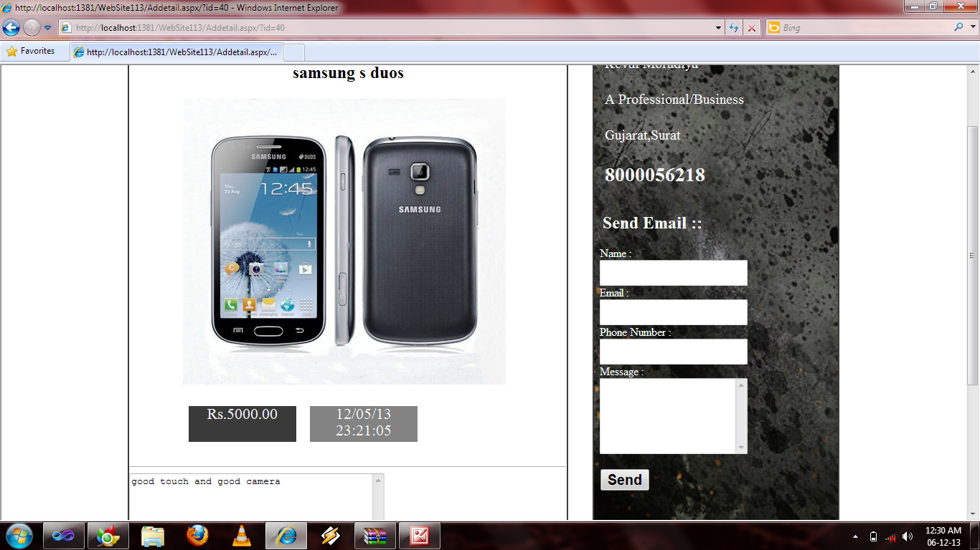

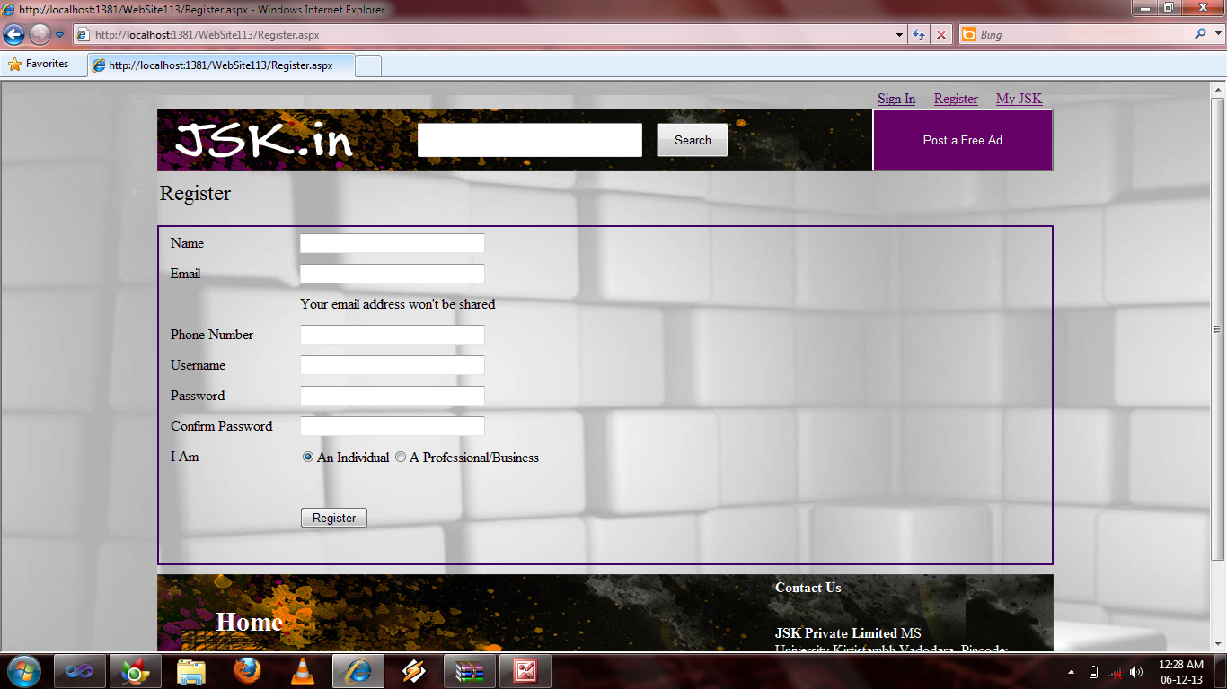

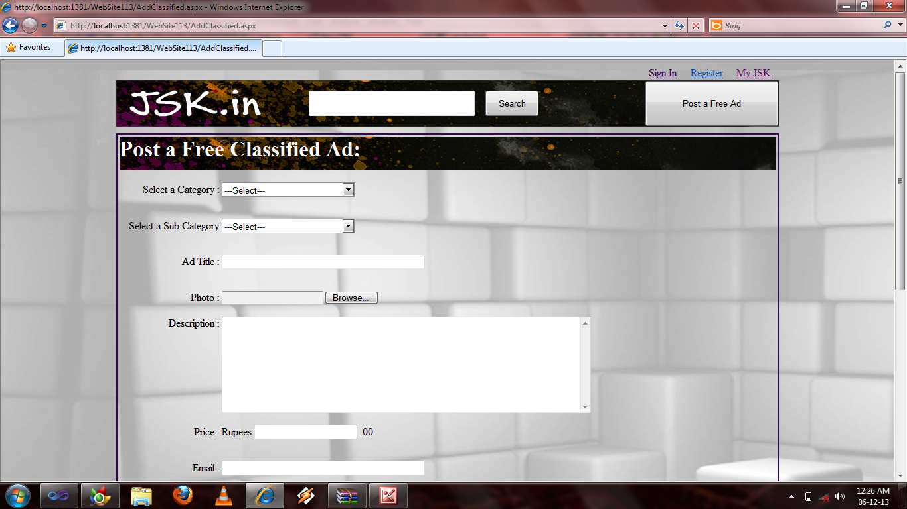

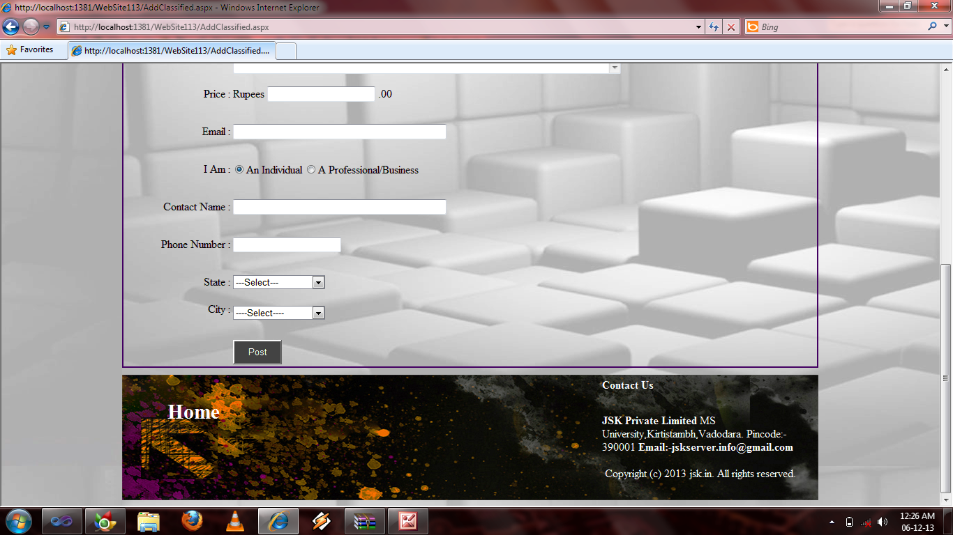

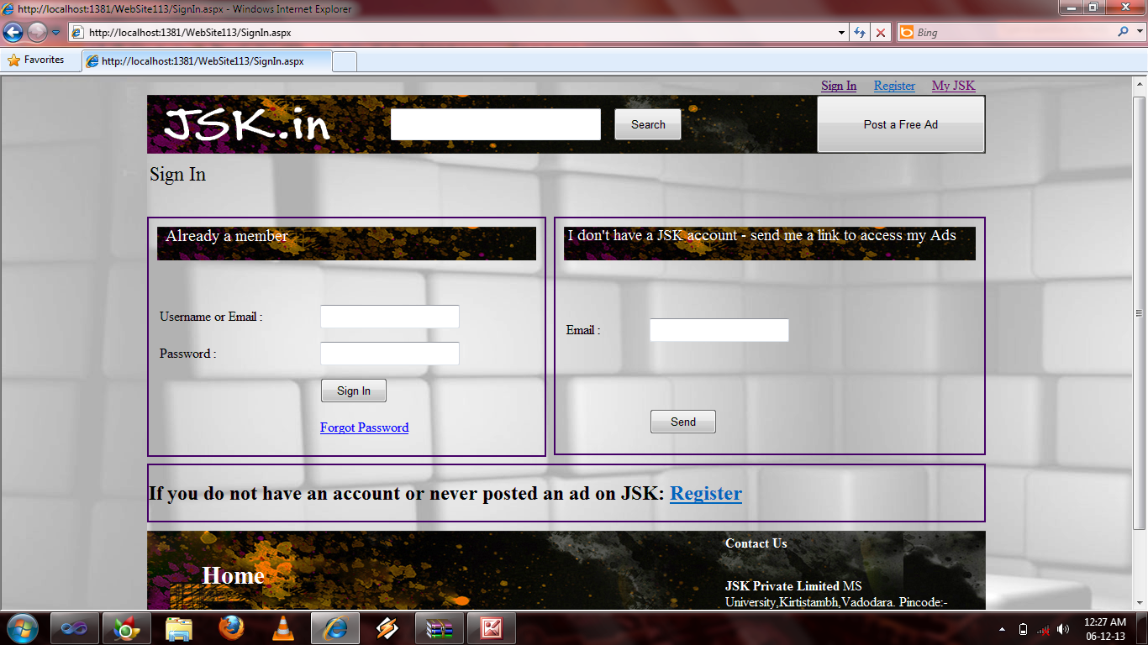

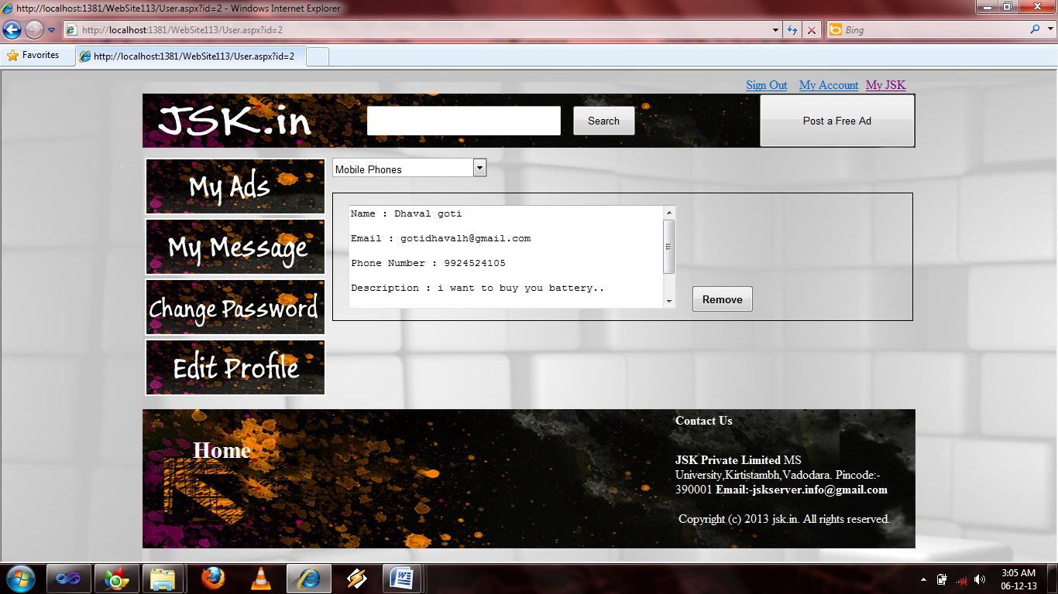

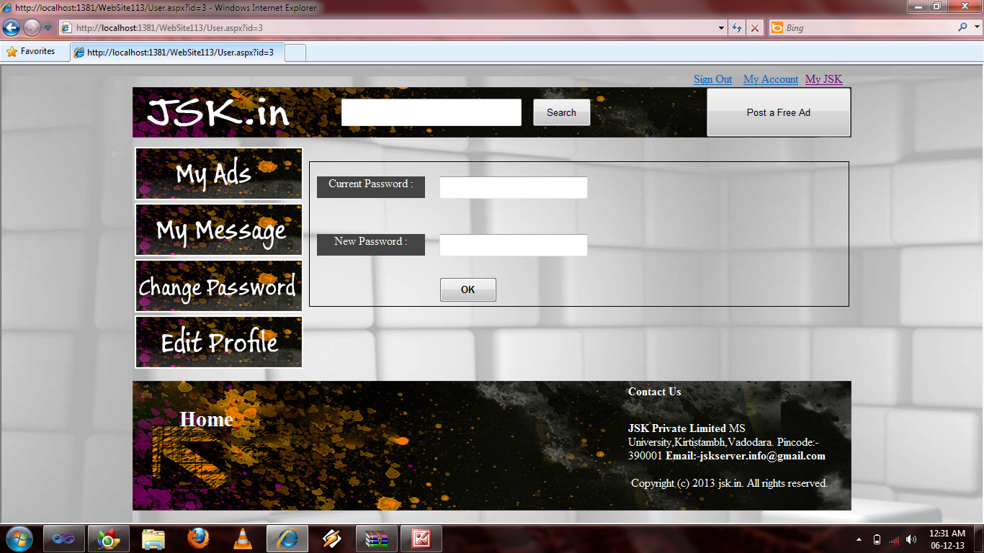

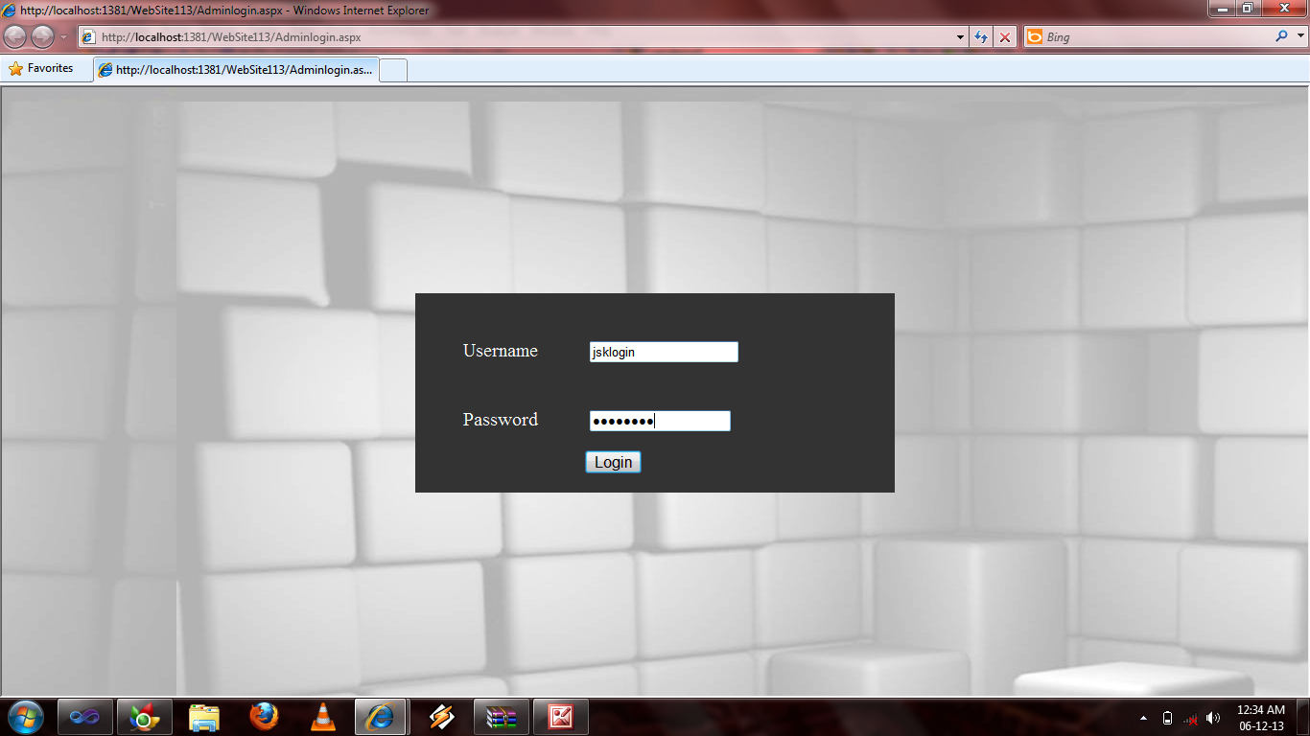

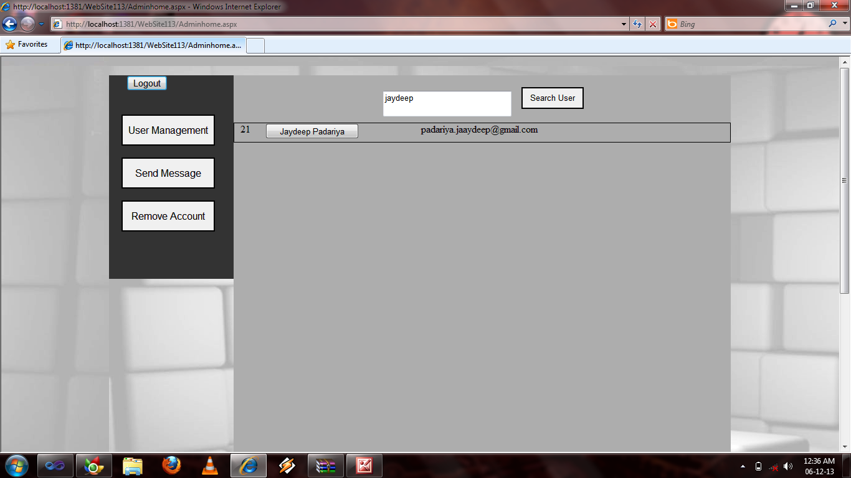

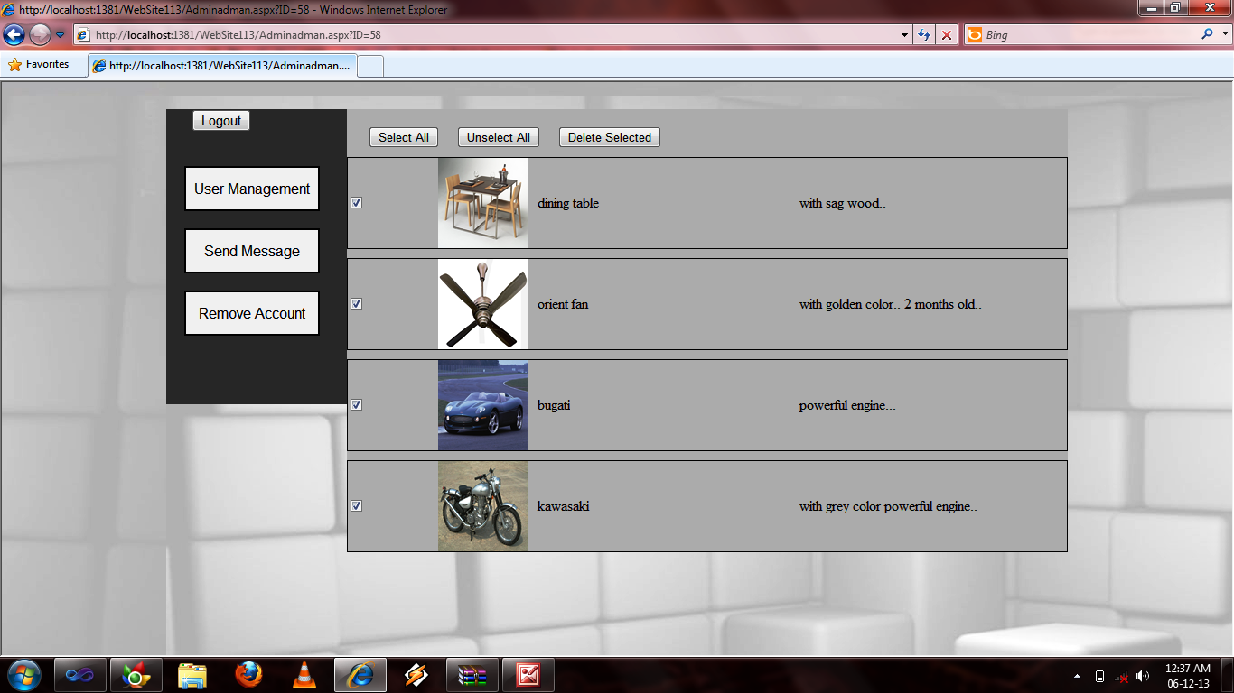

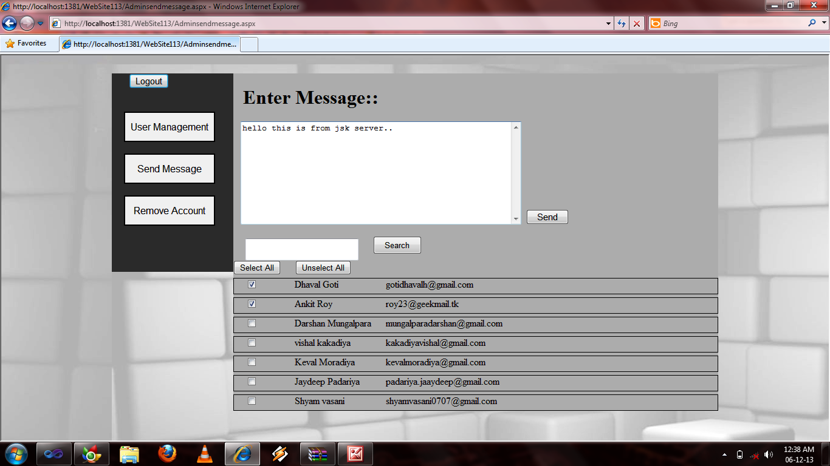

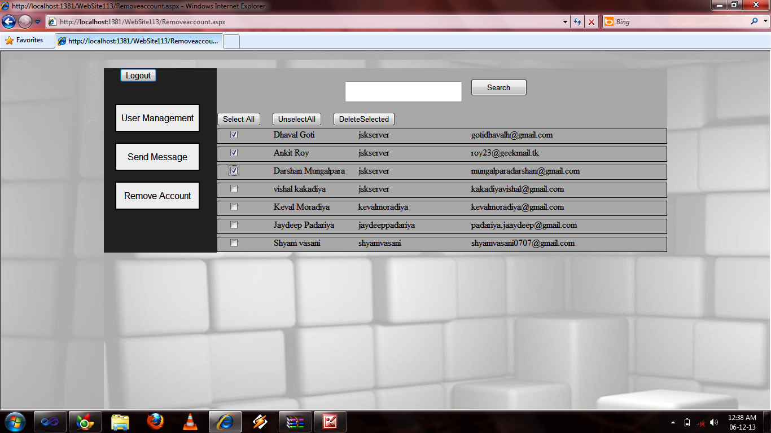

**:: Data Directory ::**

|  |  |  |  |  |
| --- | --- | --- | --- | --- |
| **Table Name ::** UserProfile | | | | |
| **Description ::** | Table to Store UserAccount Information | | | |
| **Primary Key** :: uid | | | **Foreign Key :: ---** | |
| **Column Name** | | **Data Type** | | **Allow Nulls** |
| uid | | int | | **N** |
| username | | varchar(50) | | **N** |
| password | | varchar(50) | | **N** |

|  |  |  |  |  |
| --- | --- | --- | --- | --- |
| **Table Name ::** UserInfo | | | | |
| **Description ::** | Table to Store User’s Personal Information | | | |
| **Primary Key** :: id | | | **Foreign Key ::**uid | |
| **Column Name** | | **Data Type** | | **Allow Nulls** |
| id | | int | | **N** |
| cname | | varchar(50) | | **N** |
| email | | varchar(50) | | **N** |
| phoneno | | decimal(13,0) | | **N** |
| iam | | int | | **N** |
| uid | | int | | **N** |

|  |  |  |  |  |
| --- | --- | --- | --- | --- |
| **Table Name ::** Usermsg | | | | |
| **Description ::** | Table to Store User Messages | | | |
| **Primary Key** :: id | | | **Foreign Key ::**uid | |
| **Column Name** | | **Data Type** | | **Allow Nulls** |
| id | | int | | **N** |
| uid | | int | | **N** |
| name | | varchar(50) | | **N** |
| email | | varchar(50) | | **N** |
| phonenumber | | varchar(13) | | **N** |
| description | | varchar(MAX) | | **N** |
| idp | | int | | **N** |

|  |  |  |  |  |
| --- | --- | --- | --- | --- |
| **Table Name ::** postad | | | | |
| **Description ::** | Table to Store information about all the ads that has been posted | | | |
| **Primary Key** :: idp | | | **Foreign Key ::**ins,insu,idui | |
| **Column Name** | | **Data Type** | | **Allow Nulls** |
| idp | | int | | **N** |
| title | | varchar(50) | | **N** |
| image | | varchar(MAX) | | **N** |
| description | | varchar(MAX) | | **N** |
| price | | decimal(20,2) | | **N** |
| locations | | int | | **N** |
| locationc | | int | | **N** |
| date | | varchar(30) | | **N** |
| ins | | int | | **N** |
| insu | | int | | **N** |
| idui | | int | | **N** |

|  |  |  |  |  |
| --- | --- | --- | --- | --- |
| **Table Name ::** Selection | | | | |
| **Description ::** | Table to Store main category of the items to be sold | | | |
| **Primary Key** :: id | | | **Foreign Key :: ---** | |
| **Column Name** | | **Data Type** | | **Allow Nulls** |
| id | | int | | **N** |
| name | | varchar(30) | | **N** |

|  |  |  |  |  |
| --- | --- | --- | --- | --- |
| **Table Name ::** subselection | | | | |
| **Description ::** | Table to Store subcategory if items to be sold | | | |
| **Primary Key** :: id | | | **Foreign Key ::**idf | |
| **Column Name** | | **Data Type** | | **Allow Nulls** |
| id | | int | | **N** |
| name | | varchar(50) | | **N** |
| idf | | int | | **N** |

|  |  |  |  |  |
| --- | --- | --- | --- | --- |
| **Table Name ::** state | | | | |
| **Description ::** | Table to Store List of all the state of India | | | |
| **Primary Key** :: id | | | **Foreign Key :: ---** | |
| **Column Name** | | **Data Type** | | **Allow Nulls** |
| id | | int | | **N** |
| state | | varchar(50) | | **N** |

|  |  |  |  |  |
| --- | --- | --- | --- | --- |
| **Table Name ::** city | | | | |
| **Description ::** | Table to Store List of all the city of any particular state | | | |
| **Primary Key** :: id | | | **Foreign Key ::**idc | |
| **Column Name** | | **Data Type** | | **Allow Nulls** |
| id | | int | | **N** |
| city | | varchar(25) | | **N** |
| idc | | int | | **N** |

* **E-R Diagram**

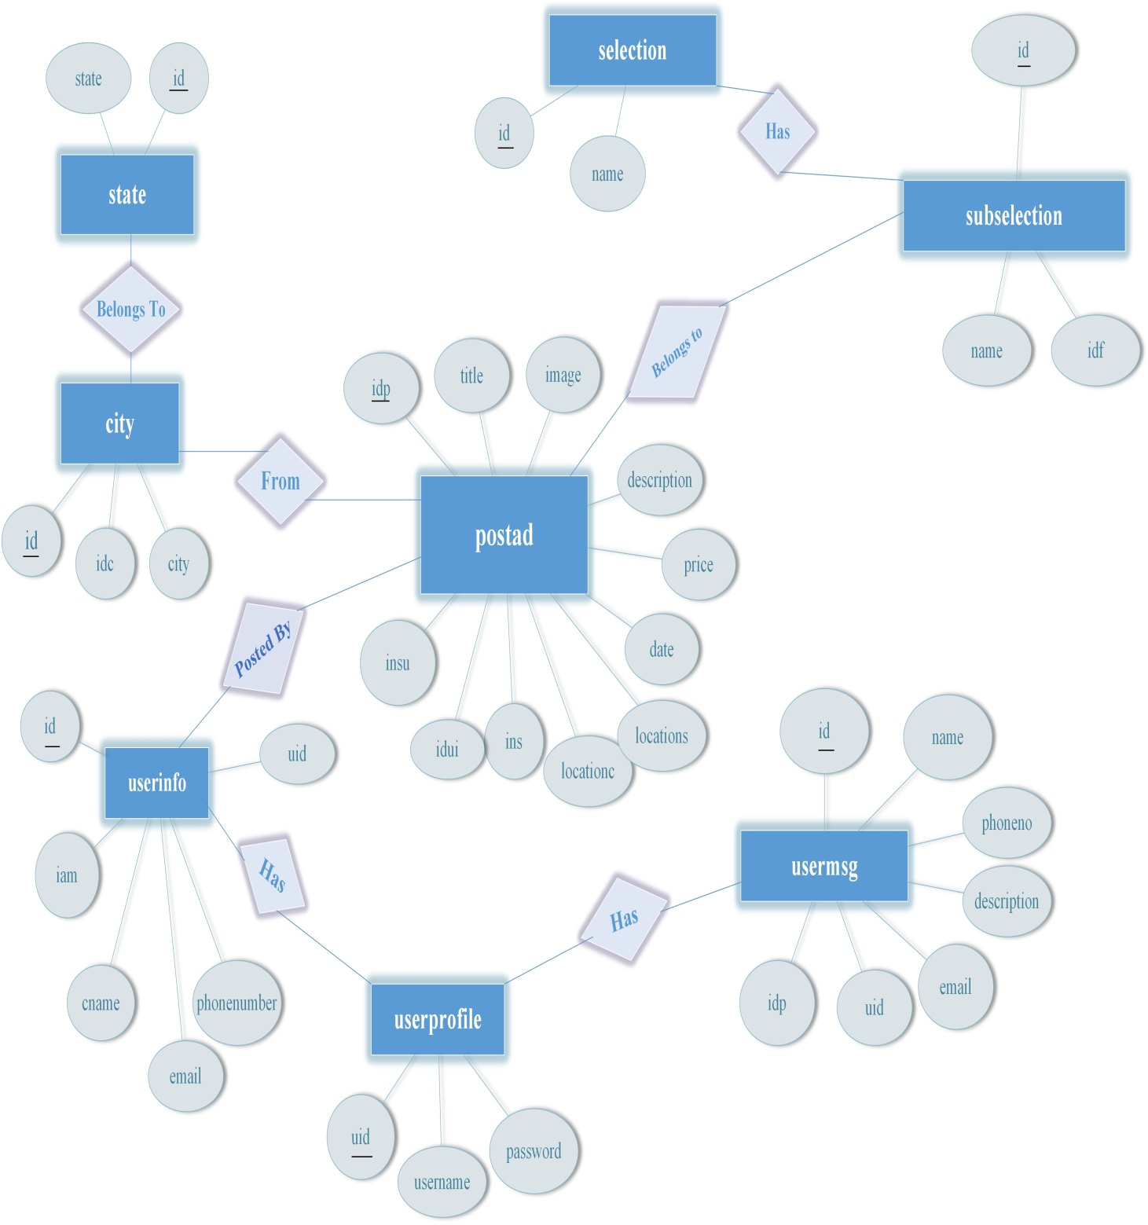

* **DFD ::**

🡪Level 0 DFD

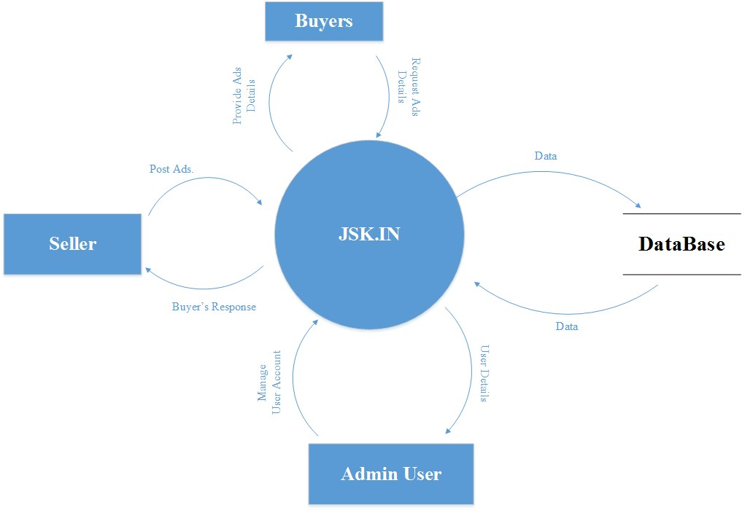

🡪Level 1 DFD

